Devops exam papers 2017-2018

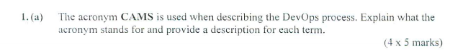

1(a) The acronym CAMS is used when describing the DevOps process. Explain what the acronym stands for and provide a description for each term. 4 * 5 marks

C is for Culture: devops is similar with agile method, it focus on people is main goal, to understand what people needs.

A is for Automation: When you write a piece of code to do a task which you would otherwise do by hand, this counts as automation

M is for Measurement/Monitoring: In order to improve something you have to be able to measure it, Monitoring can also be integrated into the release process

S is for Sharing: All stakeholders need to be aligned toward the same shared goal

Shared input will generally create shared responsibility and ownership

The team can identify problems and eliminate bottlenecks

The team should also have shared benefits

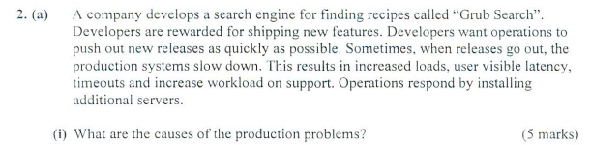

What are the causes of the production problems?

Performance problems don’t get discovered until the release is complete

New releases need more server capacity



Will the additional servers solve the problem?

New releases need more server capacity

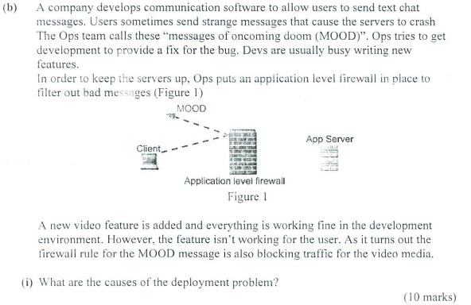

Firewalls are an important part of the production system but they’re not represented in development.

There was a bug that never got addressed by the devs because of an ops fix that was meant to be temporary.



Golden Image:

Unifying the production and development environments

Wrap up a standard / golden master image in a VM

No need to configure each new machine individually

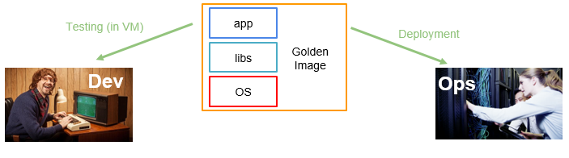

Configuration management system:

Install a base OS

Use config management system to perform automatic installation and configuration of SW on every system under its control

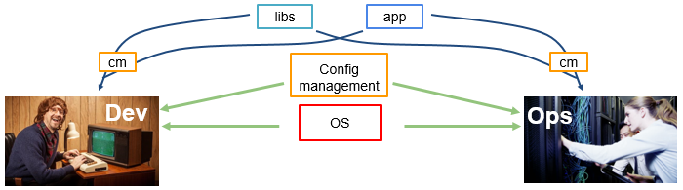

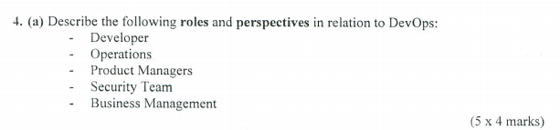

Developer:

Big launches as accomplishments

Building new features might be dependent on learning new technologies or approaches

Risk takers.

**Key role is to design, installation, testing and maintenance software system.**

**Developer have to meet customer to understand what customers needs and what software has to be.**

Operations:

Ops people run services

Incentives are more stability oriented

New untested tech or features are a potential problem for stability and performance of the system

Tend to be invisible to the organisation

Only noticed when something does not work.

**The Ops side of DevOps starts with the servers, getting them to exist and keep running, including after a change (deploy) and actually doing the deployment**.

Product Managers

PMs maybe even more feature oriented than Devs

Make external promises

May not even interact with traditional Ops staff

**Product managers also monitor the development, sales, customer support, international marketing of product.**

**they can do to help one another create better products more efficiently**

Security team

May be more change averse than Ops

Fear of introducing new unknown vulnerabilities

May be more willing to risk service downtime

**Patch newly discovered vulnerabilities quickly**

**will implement and control the needed security products to detect and deter attacks**

Business Management

**Business management are responsible for budgeting and buying resources**

**Ops may need to requisition additional resources from them**

Additional resources need to be reasoned and justified



In software testing, a **canary** is a push of programming code changes to a small group of end users who are unaware that they are receiving new code

Continuous Integration is the first part of the process

Continuous Integration is an automated process

Gets changes into existing codebases

Building and running tests

A major goal is to eliminate backlog when you go to deploy

Incident free deployments

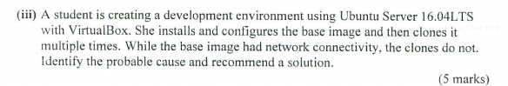

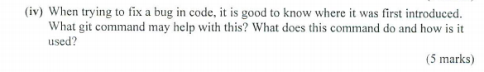

Git log command